Interfacing IR Sensor with ESP32 Devkit v1

Introduction

An **Infrared (IR) Sensor** is a versatile and widely used device that utilizes infrared radiation to detect the presence, movement, or temperature of objects. These sensors operate by detecting the infrared light emitted, reflected, or transmitted by objects. Infrared radiation has wavelengths longer than visible light, making it invisible to the human eye. However, IR sensors are specially designed to sense these wavelengths and convert them into signals that can be analyzed.

IR sensors come in two primary types: **active** and **passive**. Active IR sensors emit infrared light, typically from an LED or laser, and measure the reflection or interruption of that light from an object. Passive IR sensors, on the other hand, detect the infrared radiation emitted by objects, such as the human body or warm surfaces, without emitting any infrared light themselves.

One widely used example of an IR sensor is the **PIR (Passive Infrared) Sensor**, commonly used in security and automation systems. These sensors detect infrared radiation emitted by living beings, making them ideal for motion detection. For instance, in security systems, PIR sensors can detect the movement of people or animals and trigger alarms or activate lights. They are also commonly used in devices like automatic doors, where the sensor detects the presence of a person and initiates door opening.

Infrared sensors have numerous applications in modern technology. In **consumer electronics**, they are often used in remote controls, where the IR sensor detects signals sent from a remote control to operate devices such as TVs and air conditioners. In **robotics**, IR sensors are essential for obstacle detection, helping robots navigate their environment and avoid collisions. Similarly, **temperature sensors** often use IR technology to measure heat emitted by objects or surfaces without physical contact, making them invaluable in applications like industrial monitoring, medical thermometers, and energy-efficient systems.

Moreover, **IR sensors** are critical in fields such as **healthcare**, where they are used in devices like infrared thermometers and pulse oximeters to monitor body temperature and blood oxygen levels. They are also used in **night-vision technologies**, where the sensor detects infrared radiation emitted by objects or living beings, providing visibility in dark or low-light environments.

The simplicity, low power consumption, and non-contact detection capabilities of IR sensors have made them a popular choice in a broad range of applications. From motion detection in smart home devices to healthcare diagnostics and industrial automation, the versatility and efficiency of IR sensors continue to play a key role in advancing modern technology.

What is an Infrared Ray?

**nfrared Radiation (IR)** refers to electromagnetic waves with wavelengths longer than visible light but shorter than microwaves. These waves fall within the range of 0.7 micrometers to 1 millimeter, making them invisible to the human eye. Infrared radiation is associated with heat, as all objects, including the human body, emit IR radiation depending on their temperature. The term "infrared" comes from the Latin "infra," meaning "below," signifying that these waves exist just below the visible spectrum of light.

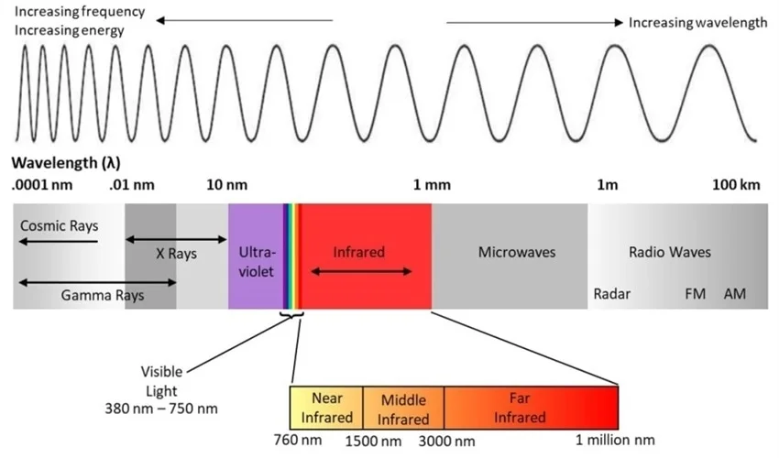

**Understanding the Infrared Spectrum**

The infrared spectrum is typically divided into three categories:

1. **Near-Infrared (0.7 µm to 1.5 µm)**: Close to the visible spectrum, this range is commonly used in communication systems and optical devices.
2. **Mid-Infrared (1.5 µm to 5 µm)**: This range is particularly useful in industrial applications, such as material testing and environmental monitoring.
3. **Far-Infrared (5 µm to 1 mm)**: This range is primarily associated with thermal radiation, such as heat emitted from the surface of objects.

The infrared spectrum also plays a role in thermal imaging, where different temperatures of objects are captured based on the intensity of infrared radiation they emit.

**Significance of Infrared Radiation**

Infrared radiation has unique properties that make it indispensable across a variety of fields. It can penetrate through certain materials, enabling applications like thermal imaging, where it is used to detect temperature variations in surfaces and objects. Infrared technology is also essential in medical diagnostics, such as infrared thermometers used to measure body temperature without contact. In security and surveillance, infrared cameras and motion sensors rely on the detection of heat from moving objects.

Beyond human applications, infrared radiation is also important in nature. For instance, many animals, like snakes, can detect infrared radiation to locate prey through specialized sensors, mimicking the human use of infrared technology for sensing and measuring temperature.

The infrared spectrum extends our capabilities far beyond what is visible to the human eye, offering numerous practical applications that improve everyday life, from medical tools to industrial processes and security systems.

Hardware Overview:

IR Sensor

The **IR (Infrared) sensor** is a widely used and versatile module for detecting the presence, movement, or distance of objects in various electronic projects. It operates using infrared light, which is emitted from an LED and detected by a photodiode or phototransistor. When the emitted infrared light hits an object, it reflects back toward the sensor, which measures the reflected light intensity or interruption. Depending on the type of IR sensor, it can either detect the distance to the object (in the case of active IR sensors) or simply sense motion or presence (as seen in passive IR sensors like PIR).

The working range of an IR sensor typically varies depending on the specific module, but it can span from a few centimeters to several meters. The sensor’s accuracy can range from a few millimeters to a few centimeters. IR sensors typically operate at a voltage of 5V or 3.3V and come with simple pin interfaces such as VCC, GND, and signal pins, making them easy to integrate with microcontrollers like Arduino or Raspberry Pi.

Due to their simple design and low cost, IR sensors are commonly used in applications like proximity sensing, object detection, motion detection (e.g., in security systems), line-following robots, and touchless switches. Their ability to detect infrared light has made them indispensable in fields ranging from home automation to robotics and industrial control systems.

The following picture shows the IR sensor:

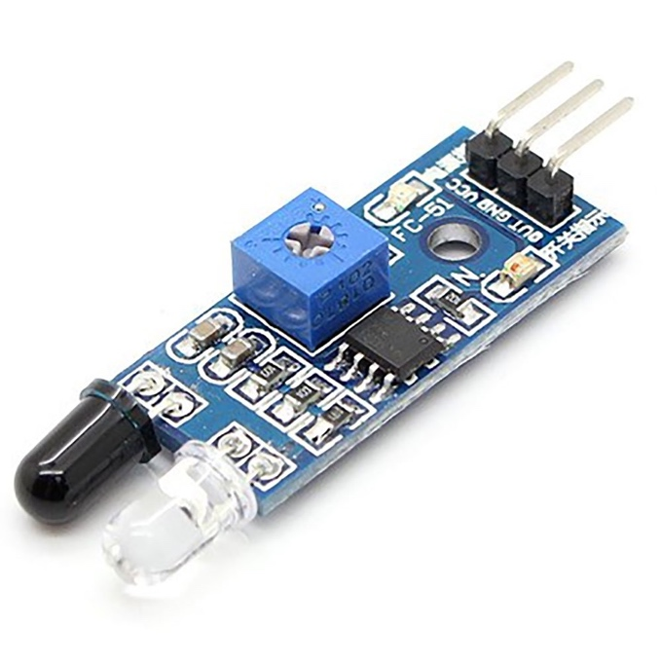

The key features of an **IR (Infrared) sensor** include:

1. **Non-contact Detection**: IR sensors can detect objects or measure distances without making physical contact, making them ideal for situations where contact is not feasible or desired.
2. **Short to Medium Range**: IR sensors generally work within a range of a few centimeters to several meters, depending on the type of sensor and the application.
3. **Active or Passive Operation**:
   * **Active IR sensors** emit infrared light and measure the reflection or interruption of the light from an object.
   * **Passive IR sensors** (such as PIR sensors) detect the infrared radiation emitted by objects (usually warm bodies) without emitting any infrared light.
4. **Low Power Consumption**: IR sensors typically consume very little power, making them energy-efficient and ideal for battery-operated devices.
5. **Simple Interface**: IR sensors often feature simple wiring with a VCC, GND, and signal pin, allowing easy integration with microcontrollers (e.g., Arduino, ESP32) and other electronic systems.
6. **Low Cost**: These sensors are inexpensive, making them accessible for hobbyists, DIY projects, and commercial applications.
7. **Wide Application Range**: IR sensors are widely used in applications such as object detection, proximity sensing, motion detection, line following in robots, security systems, and remote control devices.
8. **Compact Size**: Most IR sensors are small and lightweight, allowing them to be easily integrated into a variety of devices and systems without taking up much space.
9. **Sensitivity to Infrared Light**: IR sensors are highly sensitive to infrared light, which allows them to detect changes in heat (for passive sensors) or detect objects (for active sensors) within their detection range.
10. **Simple to Calibrate**: Many IR sensors can be easily calibrated to adjust for factors like ambient light conditions, sensor placement, and sensitivity.

Technical Specification and Pinouts

Here are the specifications:

|  |  |
| --- | --- |
| Operating Voltage | DC 3.3v - 5v |
| Operating Current | 30mA |
| Main Chip | LM393 |
| Distance Measure | 2 – 30 cm |
| Dimensions | 48 x 14 x 8 mm |
| Active output level | The output is “0” (Low) when an obstacle is detected |

IR Sensor Pinout

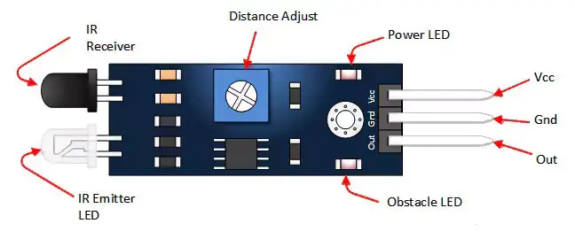

**Pin Description**

|  |  |
| --- | --- |
| Vcc | 3.3 to 5 Vdc Supply Input |
| GND | Ground Input |
| Out | The output that goes low when an obstacle is in range |
| Power LED | Illuminates when power is applied |
| Obstacle LED | Illuminates when an obstacle is detected |
| IR Emitter | Infrared emitter LED |
| IR Receiver | The infrared receiver that receives signal transmitted by Infrared emitter. |

How Does IR Sensor Work?

An **IR sensor** works by emitting infrared radiation and detecting the reflection of this radiation from objects in its environment. The sensor uses two main components:

**1. IR Transmitter (Infrared LED):**

This component emits a continuous beam of infrared light when powered. The infrared radiation is invisible to the human eye but can travel through the air and reflect off nearby objects.

**2. IR Receiver (Photodiode):**

The photodiode acts as the receiver, detecting the infrared light that reflects off an object. When the infrared light hits an object, it bounces back toward the photodiode. The photodiode then generates an electrical signal based on the intensity of the reflected light.

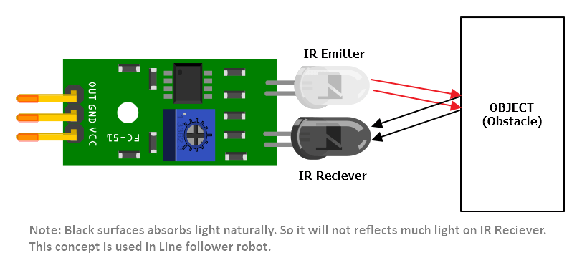

**Working Principle:**

* When power is applied to the **Infrared LED**, it emits a beam of infrared radiation.
* This light travels through the air and hits an object in the sensor's path.
* The infrared light is reflected from the object back to the **photodiode** (receiver).
* If the object is closer, the intensity of the reflected light will be stronger. As the object moves away, the reflected light becomes weaker.

The sensor processes the amount of reflected light, and if the object interrupts the beam, the sensor will output a **LOW signal**. This signal can be used by a microcontroller (e.g., ESP32) to trigger actions such as turning on a light, activating a motor, or sending a message.

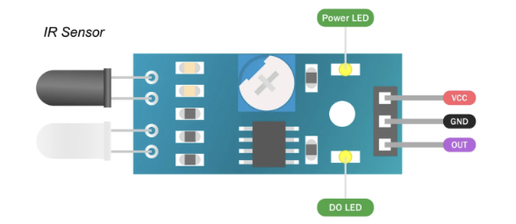

**Key Features:**

* **Two Onboard LEDs**: One LED indicates power (on when the sensor is powered), while the other LED lights up when the sensor is triggered by an object.
* **Digital Output**: The sensor outputs a digital LOW signal when the beam is interrupted, which can be read by microcontrollers like Arduino to initiate further actions.

IR sensors are commonly used for **object detection**, **proximity sensing**, and **distance measurement** in various applications, from simple obstacle-avoiding robots to more complex systems like security devices and automated control systems.

Schematic Diagram

Circuit Diagram of connecting ESP32 to IR sensor

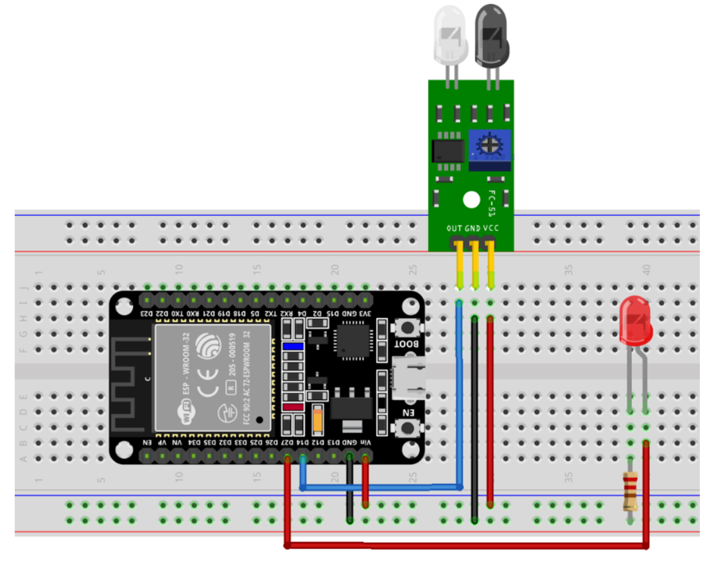

Wiring ESP32 devkit to IR sensor

Connecting the IR Sensor to ESP32 devkit v1 is very easy. Start by placing the sensor on your breadboard. Connect the VCC pin to the Vin pin on the ESP32 devkit v1 and the GND pin to the ground pin. Now connect the OUT pin to GPIO D14 and LED’s Long leg to GPIO D27 and Short leg to GND.

The following table lists the pin connections:

|  |  |
| --- | --- |
| IR Sensor | ESP32 Devkit v1 |
| VCC | VIN |
| OUT | D14 |
| LED’s Long Leg | D27 |
| GND | GND |

Uploading Code

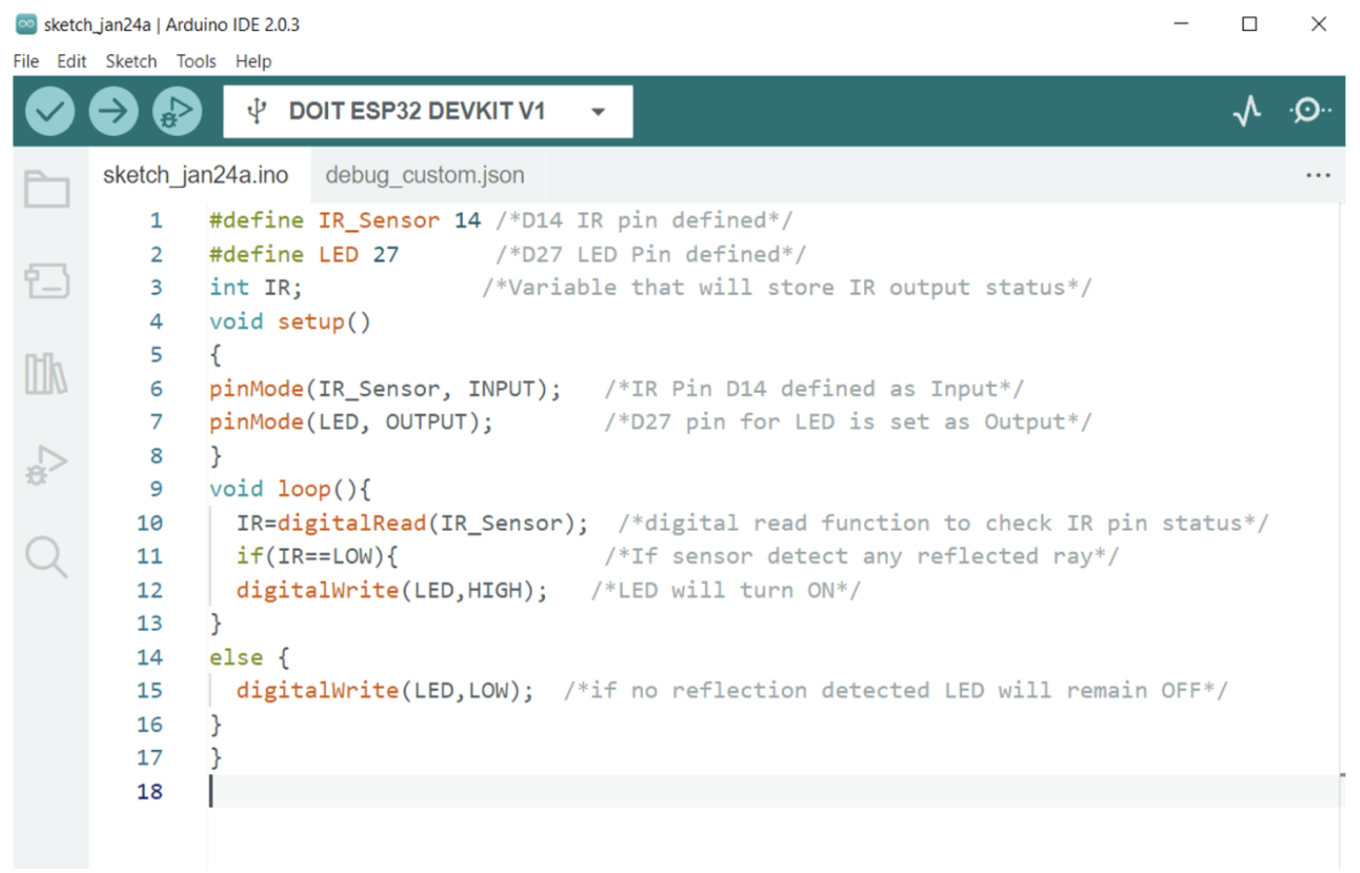

Output:

After uploading code to the ESP32 board, we can test the circuit by using any object which comes in front of the infrared sensor.

Below given image shows LED is **OFF** as IR radiations are not reflected by any of the objects. Sensor is not triggered which means it will send a **HIGH** signal at its output pin.

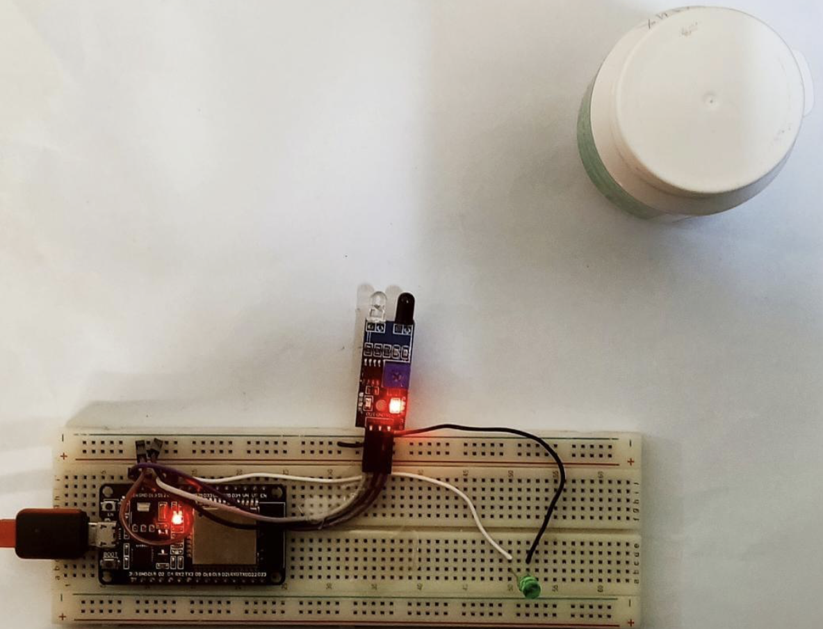

Now as the object is in front of the IR sensor, radiation gets reflected and received by the photodiode on the IR sensor, so the LED is turned **ON**. In this case a **LOW** signal will be generated by an IR sensor.

